CI/CD Pipeline assignment –18thJan

1. Jenkins CI CD pipeline for flask application
Step-by-step instructions to install Jenkins on an Ubuntu 22.04 LTS virtual machine, configure Python, install common Python libraries, and verify that Jenkins can run Python jobs.

Assumptions
- Ubuntu 22.04 LTS (Desktop or Server) is running in a virtual machine (e.g., VirtualBox/VMware).

Part 1 — Install Jenkins on Ubuntu

1. Update System Packages
sudo apt update && sudo apt upgrade -y

2. Install Java (Jenkins Requirement)
Jenkins requires Java. We will use OpenJDK 17:
sudo apt install -y openjdk-17-jdk
java -version
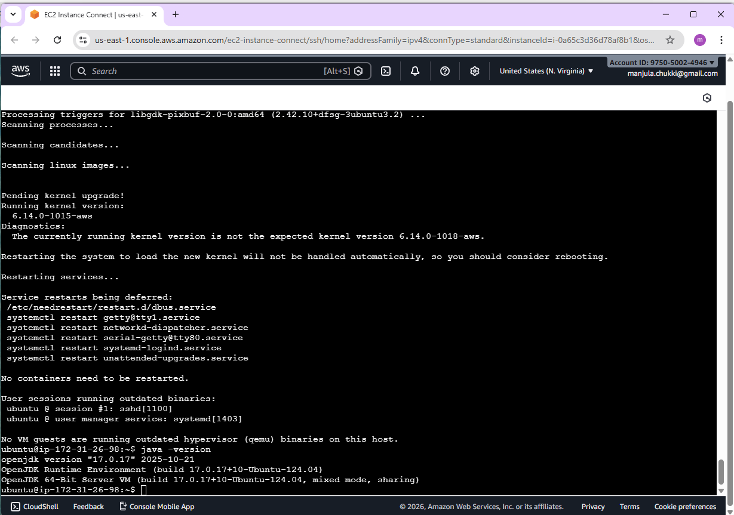

3. Add Jenkins Official Repository
Add the Jenkins key and repository:
curl -fsSL https://pkg.jenkins.io/debian-stable/jenkins.io-2023.key | sudo tee /usr/share/keyrings/jenkins-keyring.asc > /dev/null

echo deb [signed-by=/usr/share/keyrings/jenkins-keyring.asc] https://pkg.jenkins.io/debian-stable binary/ | sudo tee /etc/apt/sources.list.d/jenkins.list > /dev/null

4. Install Jenkins
sudo apt update
sudo apt install -y Jenkins
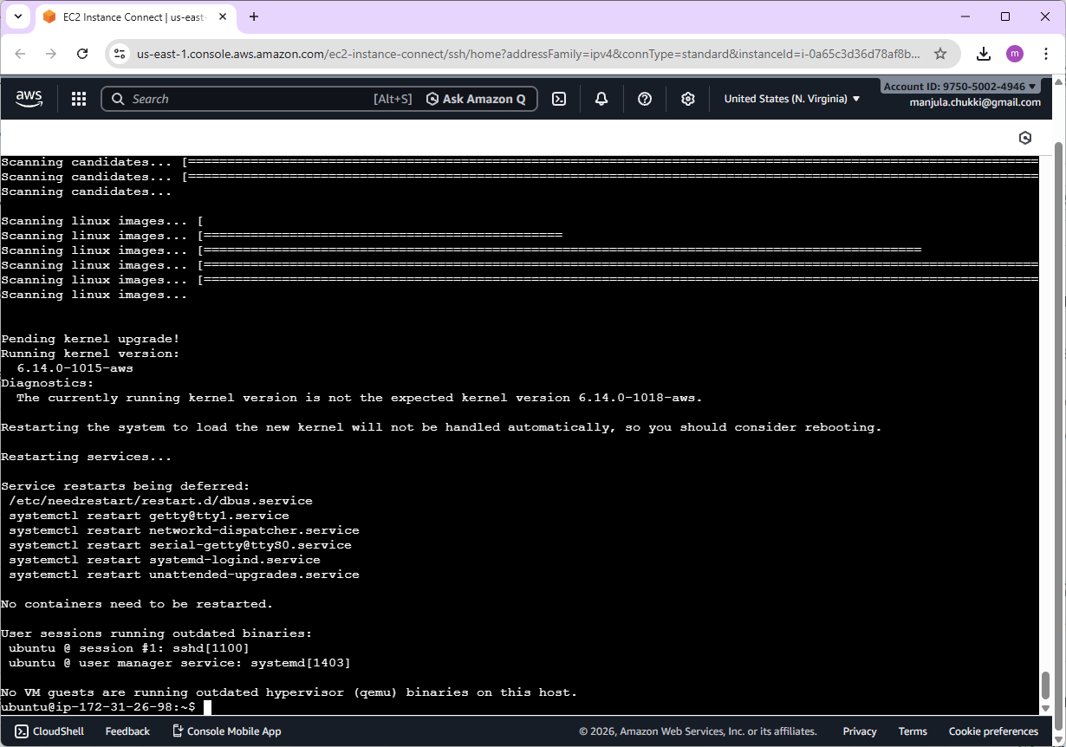

5. Start and Enable Jenkins Service
sudo systemctl start jenkins
sudo systemctl enable jenkins
sudo systemctl status Jenkins
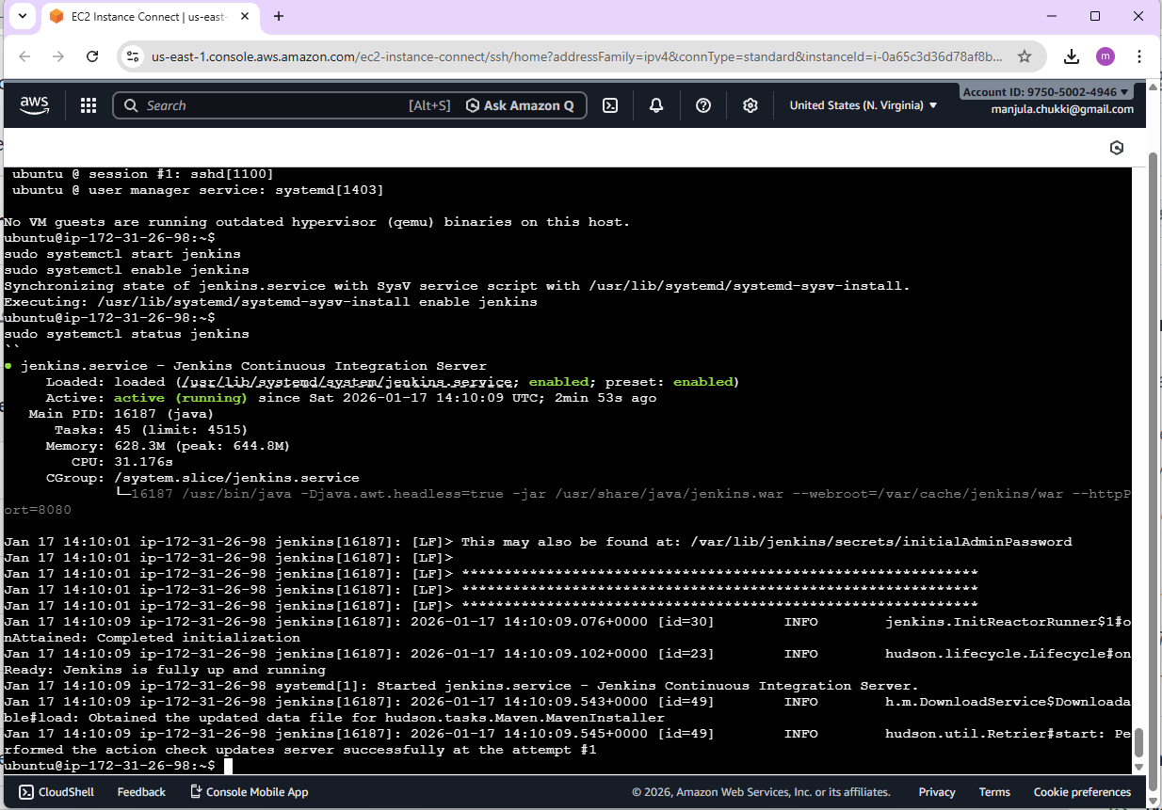

6. Open Firewall Port 8080 (if UFW is enabled)
sudo ufw allow 8080
sudo ufw reload
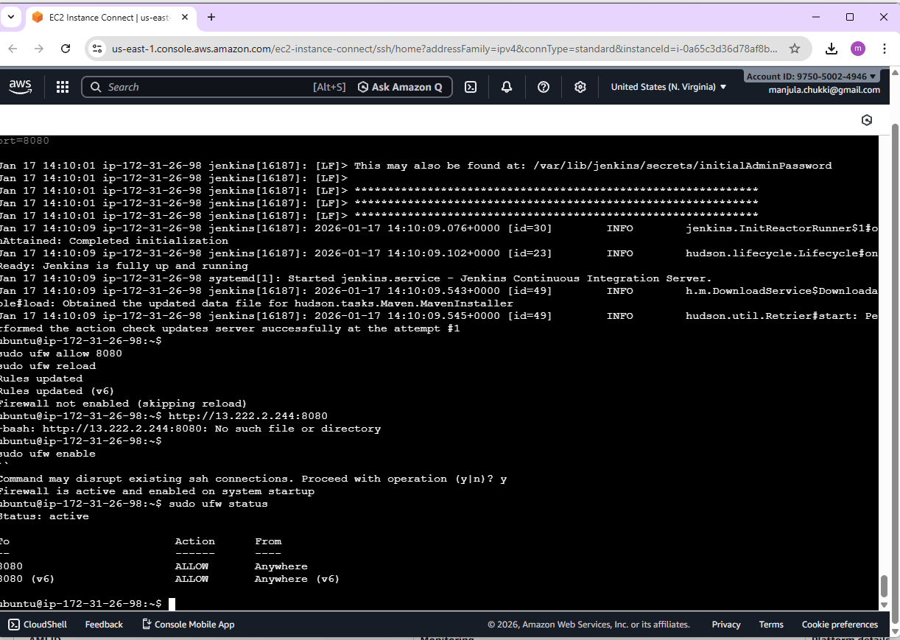

7. Access Jenkins UI
- From the VM: http://localhost:8080
- From host machine: http://<VM-IP>:8080 (replace with your VM IP)

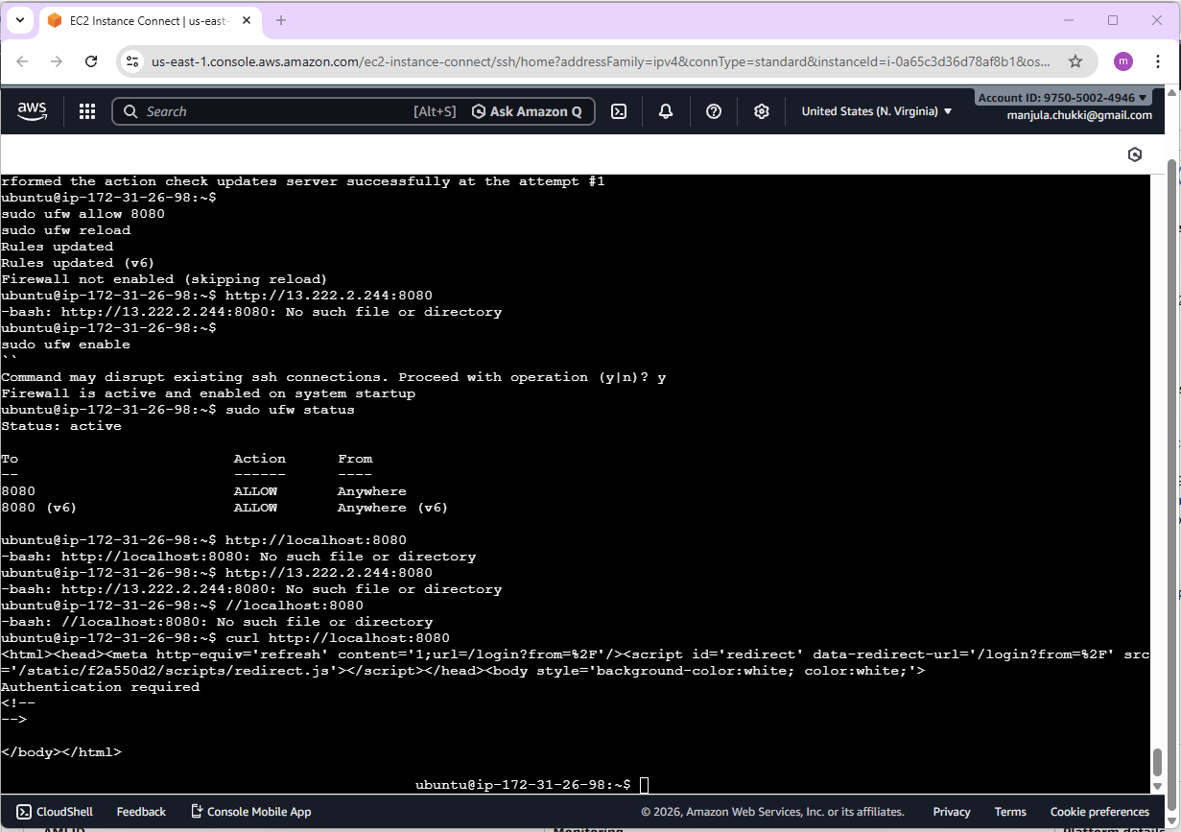

8. Unlock Jenkins
Retrieve the initial admin password and paste it into the Jenkins setup screen:
sudo cat /var/lib/jenkins/secrets/initialAdminPassword
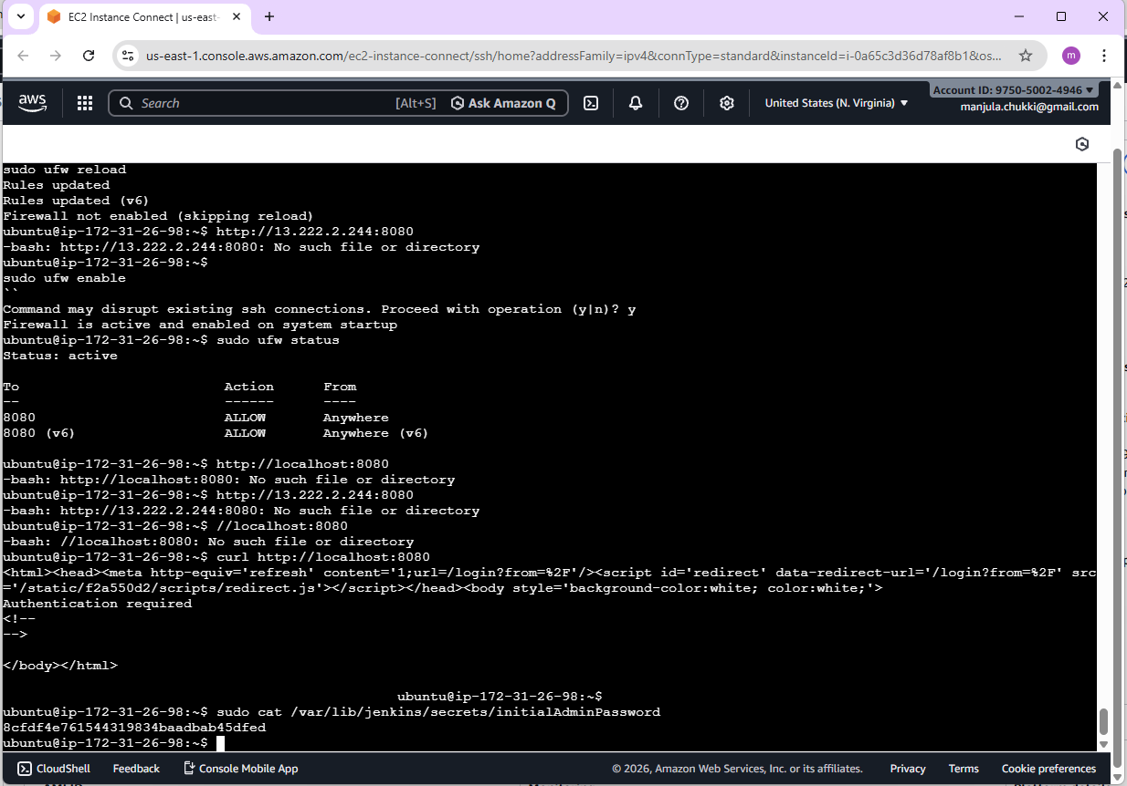

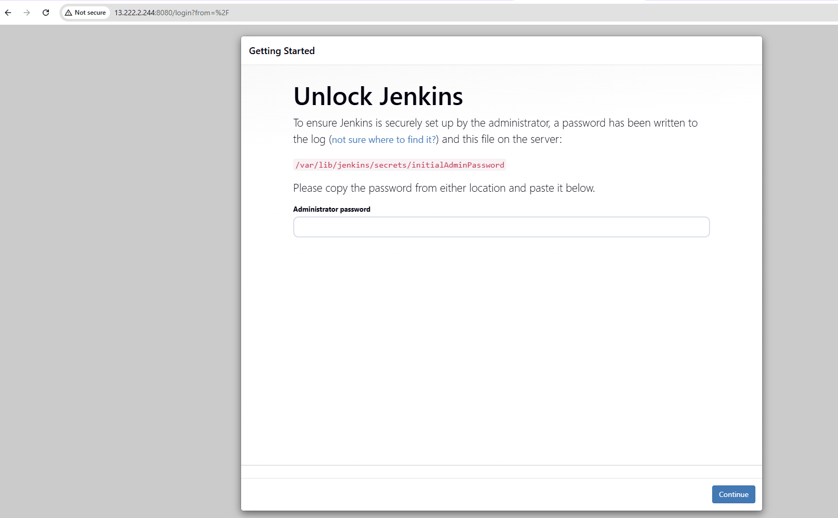
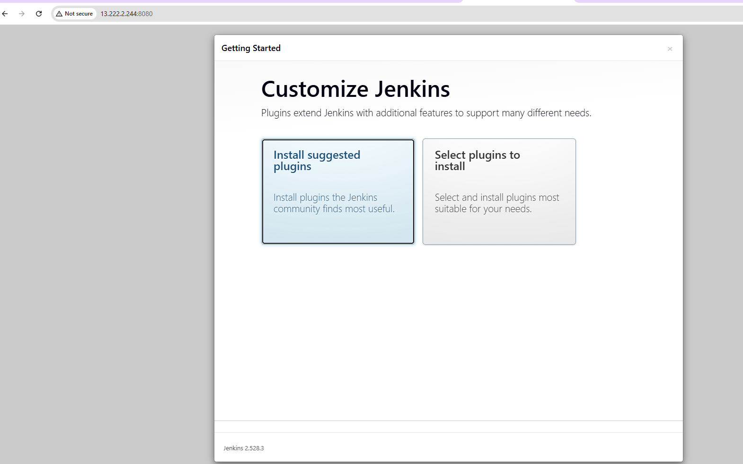

9. Initial Setup
- Install Suggested Plugins
- Create the first admin user (username, password, email)

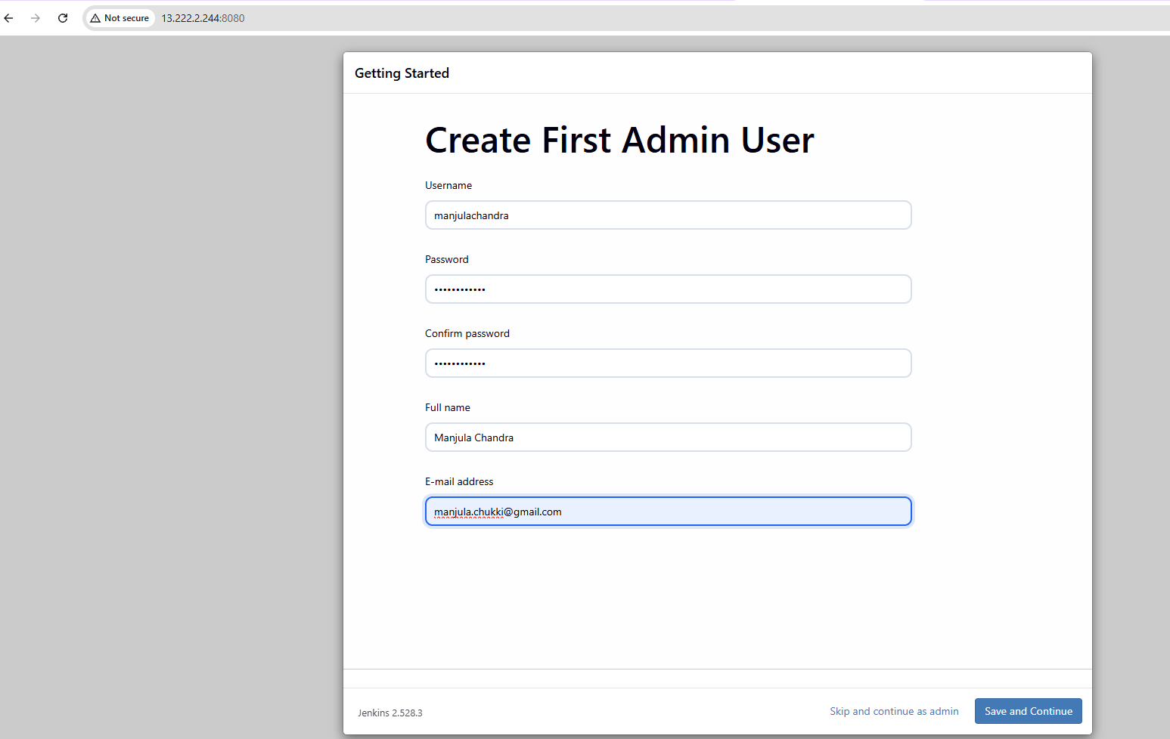

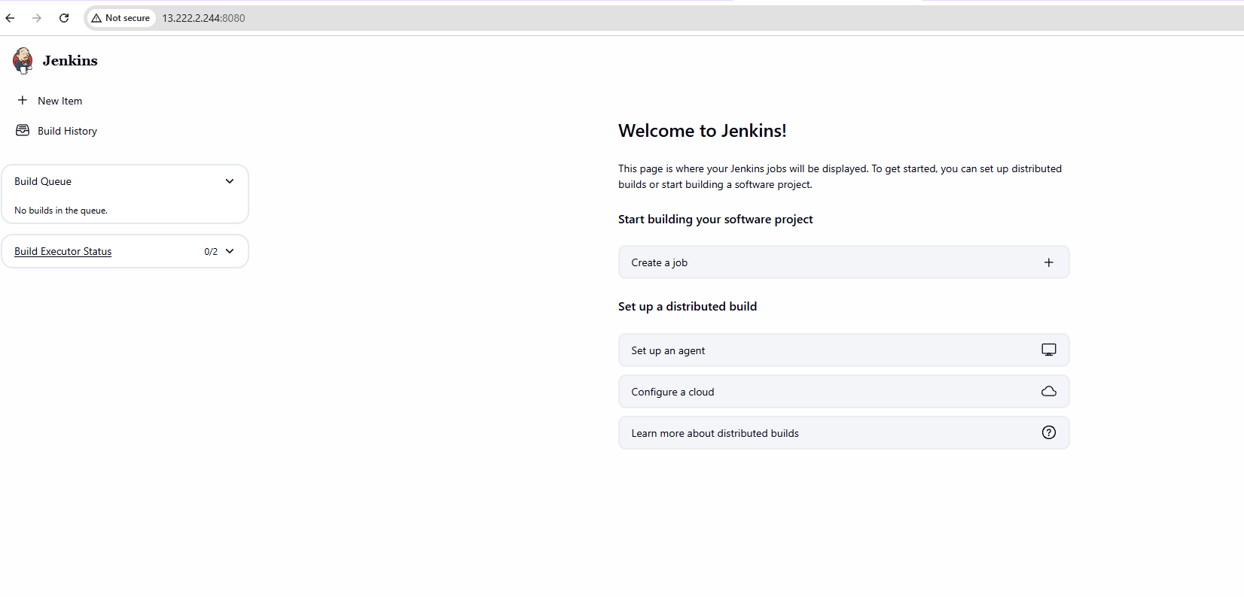

Part 2 — Install Python on the VM

1. Install Python, Pip, and venv
sudo apt install -y python3 python3-pip python3-venv
python3 --version
pip3 –version
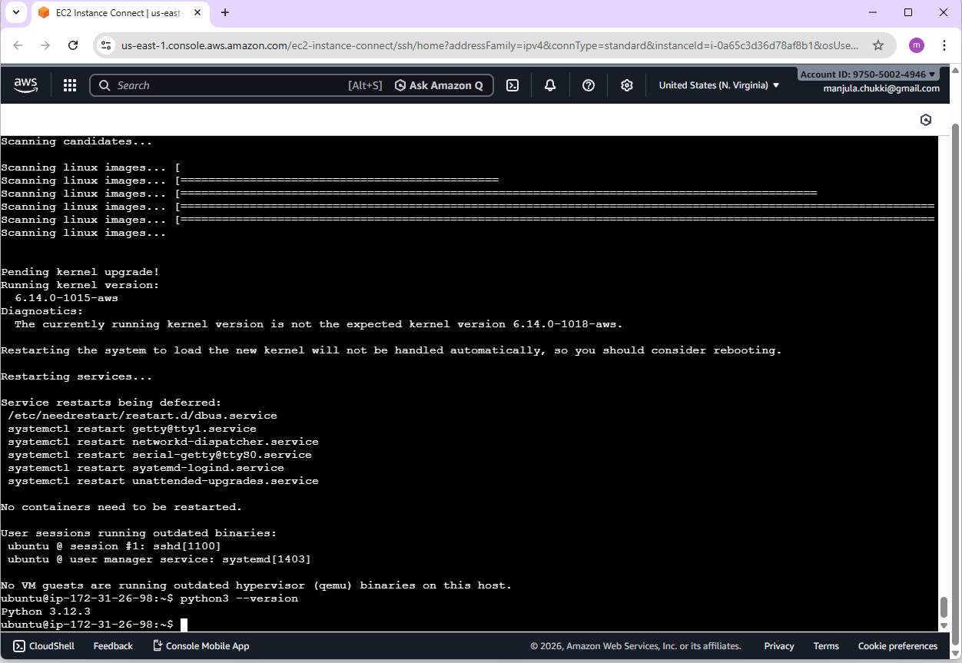

2. Install Common Python Libraries
Install commonly used libraries system-wide (convenient for Jenkins):
sudo pip3 install requests flask pytest numpy pandas

3. Verify Python Packages
python3 -c "import requests, flask, pytest, numpy, pandas; print('OK')"

Part 3 — Configure Python in Jenkins

Option A: Use System Python (Simple)
Jenkins can invoke /usr/bin/python3 directly in build steps. No extra configuration is required.

Option B: Register Python in Global Tool Configuration (Recommended)
- Jenkins Dashboard → Manage Jenkins → Global Tool Configuration
- Scroll to Python → Add Python
- Name: python3
- Path: /usr/bin/python3
- Save

Part 4 — Create a Test Jenkins Job for Python
- Click “New Item” → Name: python-test-job → Freestyle project → OK
- Add build step: Execute shell
Paste the following script to validate Python in Jenkins:
python3 --version
pip3 --version

python3 - <<EOF
import sys
import requests
print("Python executable:", sys.executable)
print("Requests version:", requests.__version__)
EOF

- Click “Save” → “Build Now” and verify the console output shows versions and SUCCESS

Part 5 — Optional: Use a Virtual Environment per Job
Best practice is to isolate dependencies per job using Python virtual environments:
python3 -m venv venv
source venv/bin/activate
pip install --upgrade pip
pip install requests pytest
python -c "import requests, pytest; print('venv OK')"

Use the above as your Jenkins build step for projects requiring isolated dependencies.

Troubleshooting Tips
- Jenkins not reachable: Ensure the service is running and port 8080 is open (UFW/NAT).
- Java errors: Confirm OpenJDK 17 is installed and JAVA_HOME is not misconfigured.
- Permission issues: Prepend commands with sudo when needed or adjust permissions for Jenkins user.
- Python module not found: Ensure packages are installed system-wide or inside the active virtual environment.

2. GitHub Actions CI/CD Pipeline Flask App
GitHub Actions pipeline for a Python application that uses a main branch (production) and a staging branch (pre-production). It runs tests, builds the app, deploys to staging on pushes to staging, and deploys production on release tags.

1. Ensure Branch Structure

1.1 Create Required Branches
- main → Production
- staging → Pre-production / QA

Commands (if staging does not exist):
git checkout -b staging
git push -u origin staging
Protect the main branch by requiring PR reviews and passing checks (CI jobs).

2. Create GitHub Actions Workflow Directory

2.1 Create the directory
mkdir -p .github/workflows

2.2 Create a workflow YAML file
.github/workflows/python-ci-cd.yml

3. Define the GitHub Actions Workflow

3.1 Basic Workflow Triggers
name: Python CI/CD Pipeline

on:
push:
branches:
- main
- staging
tags:
- "v*.*.*"
pull_request:
branches:
- main
- staging

4. Install Dependencies Job

4.1 CI Job (Install + Test + Build)
jobs:
ci:
name: Install, Test, and Build
runs-on: ubuntu-latest

steps:
- name: Checkout Code
uses: actions/checkout@v4

- name: Set up Python
uses: actions/setup-python@v5
with:
python-version: "3.11"

- name: Install dependencies
run: |
python -m pip install --upgrade pip
pip install -r requirements.txt

5. Run Tests Using Pytest

5.1 Add Test Execution Step
- name: Run Tests
run: |
pytest --maxfail=1 --disable-warnings -v

6. Build Step (After Tests Pass)

6.1 Example Build Step
- name: Build Application
run: |
python setup.py sdist bdist_wheel

7. Deploy to Staging (on staging branch)

7.1 Staging Deployment Job
deploy-staging:
name: Deploy to Staging
runs-on: ubuntu-latest
needs: ci
if: github.ref == 'refs/heads/staging'

steps:
- name: Checkout Code
uses: actions/checkout@v4

- name: Deploy to Staging
env:
STAGING_API_KEY: ${{ secrets.STAGING_API_KEY }}
run: |
echo "Deploying to staging..."
./deploy/staging.sh

8. Deploy to Production (on release tags)

8.1 Production Deployment Job
deploy-production:
name: Deploy to Production
runs-on: ubuntu-latest
needs: ci
if: startsWith(github.ref, 'refs/tags/v')

steps:
- name: Checkout Code
uses: actions/checkout@v4

- name: Deploy to Production
env:
PROD_API_KEY: ${{ secrets.PROD_API_KEY }}
run: |
echo "Deploying to production..."
./deploy/production.sh

9. Store Environment Secrets Securely
- Go to Repository → Settings → Secrets and variables → Actions → New repository secret
- Add STAGING_API_KEY, PROD_API_KEY, and any other keys or tokens
- Secrets are encrypted and injected at runtime; never hardcode credentials

